Supervising construction work with OSHA guidelines
On the Handout drive/OC/Advanced Design OSHA training from https://www.osha.gov/hazfinder/
Run the OSHA training program for construction site managers.
Choose the construction site.
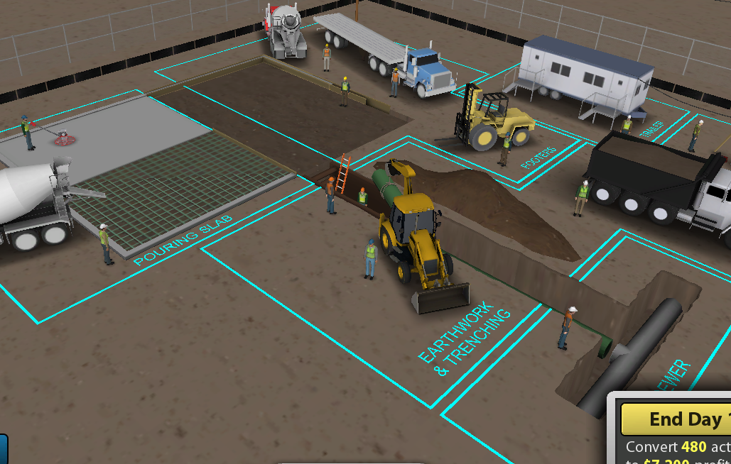
Run the tutorial
Play the game.
List some of the problems you found and fixed.
- A problem with equipment_______________________________________________
- A problem a person told you about ________________________________________
- A problem with the site _________________________________________________
- A problem with a severity of 5 ____________________________________________
- A low level problem with just 1’s or 2’s _____________________________________
Describe 3 things that you learned.
- ______________________________________________

- ______________________________________________

- ______________________________________________

